Table S1. The accession numbers of selected datasets selected from FANTOM
Cell type | Accession number
Mesenchymal stem cells | CNhs11344.11536-120A6
 | CNhs12100.11616-122A5
 | CNhs12126.11697-123A5
Non-mesenchymal lineages | CNhs11051.11376-118A8
 | CNhs11969.11327-117E4
 | CNhs12494.11259-116F8
 | CNhs11371.11336-117F4
 | CNhs12017.11408-118E4
 | CNhs11373.11339-117F7
 | CNhs12021.11411-118E7
 | CNhs11083.11281-116I3
 | CNhs12053.11451-119A2
 | CNhs12056.11455-119A6
 | CNhs12060.11459-119B1
 | CNhs12338.11494-119E9
 | CNhs12726.11574-120E8
 | CNhs13815.11655-122E8
 | CNhs11311.11276-116H7
 | CNhs11980.11353-117H3
 | CNhs12035.11425-118G3
 | CNhs12639.11763-123H8
 | CNhs12640.11765-123I1

Table S2. The list of genes identified as hub in the each lineage network (Based on the Betweenness centrality and Degree).
Cell lineages
Osteocyte | Chondrocyte | Adipocyte | Myocyte | Neurocyte | Tenocyte
TGFB1  BIRC5  IL6  FGF2  CDK1  BMP2  DCN  RUNX2  AURKA  COL2A1  CENPA  FOXM1  TWIST1  PPARG  SP1  CCNB1  CTNNB1  PLK1  SHMT2  TCF3  BMP4  CDC20  RRAGD  MAD2L1  SPP1  CCL2  AURKB  STAT3  HAND1  PTGDS  FOXO1  RARRES3  CXCL12  CCNA2  MMP1  ANXA1  SP7  MYBL2  TOP2A  IL1B  HIST1H4A  CDC25A  ZBTB16  MEN1  NCOR2  BMP7  ITGA5  MYL9  MCM7  CDC45  SMAD5  SMAD1  CHI3L2  ITGA11  ACTA2  FMOD  MFAP2  HIST1H1B  MCM2  PTGS2  COL1A1  SLPI  MSX1  MSX2  COL15A1  CCNB2  HSPB2  EGR2  NRGN  HIST4H4  UBE2C  ZBED1  IBSP  ITGB3BP  COL14A1  ATF4  AGT  ASF1B  CRYAB  OGN  GDF2  ADIPOQ  KRT6A  PTTG1  RAC2  KLF10  CHN1  SFRP4  HIST1H2BM  IGFBP5  TRIP13  PTK2B  SAA1  C1S  PTGIS  ELN  HIST1H1A  CXCL6  PRELP  SLC17A9  HIST1H2AI  HIST1H2AL  HIST1H3A  HIST1H2BB  HIST1H2BH  HIST1H2BL  HIST1H2BO  HIST1H3B  HIST1H3E  HIST1H3C  HIST1H3F  HIST1H3I  HIST1H3J  HIST1H3H  HIST1H3D  HIST1H3G  HIST1H4H  HIST1H2BG  HIST1H2BC  HIST1H2BE  HIST1H2BF  HIST1H2BI  HIST1H4B  HIST1H4C  HIST1H4D  HIST1H4E  HIST1H4F  HIST1H4I  HIST1H4J  HIST1H4K  HIST1H4L  HIST2H4A  HIST2H4B  KIF2C  CDCA8  ZWINT  SPC24  CDCA5  COL11A1  CDT1  COL3A1  MCM5  KIF18B | MMP2  SMAD3  FOXO3  IGF1  CBX5  SOX9  CCNG2  FAP  MCM2  IL6  CD55  ASF1B  BMP2  MMP13  ADD3  COL2A1  RASD2  TGFB1  ITGB1  NGEF  FGF2  ACAN  RHOJ  IL1B  GDF5  MMP9  CILP  CXCL12  KCTD16  FLNC  PCDH1  TMSB15A  CD44  MAP3K8  HIST4H4  SCRG1  DCN  KY  GMDS  DEFB1  NKX3-2  HIST1H3J  HIST1H3B  HIST1H3A  TMEM59L  CDCA8  MFAP5  FGFR3  SCG5  GAS7  KALRN  BARX2  EFEMP1  CDK2AP1  C15orf48  CA9  CLU  LECT1  PTH  HPD  TRAF4  EPB41L3  PTGS2  NT5E  NOD2  COL3A1  NNAT  FGF1  IGFBP5  ARHGEF2  UBD  FNDC1  FOXO1  SHC4  NFATC2  HLA-F  NFATC3  CTGF  EGR2  CCL5  PENK  MLPH  LSP1  COL10A1  ANGPTL7  HIST1H2AI  HIST1H2AE  HIST1H2AB  LPAR4  C2  SYBU  LUM  NRN1  KIAA1199  S100B  POSTN  SDK2  ERG  MMP1  HHIPL2  HIST1H2BC  HIST1H2BH  HIST1H2BG  HIST1H2BF  HIST1H2BE  HIST1H1D  COL11A1  IGFBP3  COL14A1  HIST1H4H  HIST1H4A  COL5A1  SERPINE2  HIST2H4B  HIST2H4A  HIST1H4L  HIST1H4K  HIST1H4J  HIST1H4I  HIST1H4F  HIST1H4E  HIST1H4D  HIST1H4C  HIST1H4B  COL9A3  COL9A2  CXCL10  ADORA1  TGM2  HIST1H3I  HIST1H3H  HIST1H3G  HIST1H3F  HIST1H3E  HIST1H3D  HIST1H3C  FMOD  CRYAB | PPARG  FABP4  MYBL2  CEBPA  SIRT1  PPARGC1A  FOXO1  FOXM1  LEP  OAS1  PBX1  CENPA  WNT3A  SREBF1  UCP1  IGF1  PLK1  BMP2  SOX11  EBF1  ADIPOQ  HIST1H1A  DDIT3  BIRC5  DLK1  LIMS2  CD36  NFYB  TPM1  LIMD2  LEF1  KIAA0040  CCNB2  MMP2  HIST1H4A  CIT  NEDD4L  E2F1  SLC16A3  MYCBP2  HIST1H2BE  LRP1  RBP4  HIST1H4B  BMP4  GPR133  MCM7  GPC4  HS2ST1  TCF7L2  HIST4H4  COMP  SPC25  KRT5  MXD3  TEAD4  GREM1  HIST1H3H  UBE2C  CD24  LMO7  SLC7A2  LIMS1  PITX1  RRM2  EPHA2  MMP1  NCAPD2  NCAPH  UTY  HTR2A  PLA2G2A  SLC2A4  ADRA2A  APOE  RETN  DAB1  BGLAP  SLC14A1  SMPD1  EDNRB  KRT16  ACTC1  CPA4  RHOU  NBL1  SLPI  AMBRA1  CTSK  DNAJC15  DLK2  DUT  ZEB1  MND1  NTM  PLXDC2  PSG4  IGF1  LGALS12  MFAP5  LPL  GATA2  CDC25A  WNT11  WNT2B  CDC20  FGF7  LDLR  KIF18B  NOG  FYN  ACVRL1  ADIPOR1  ADIPOR2  CENPM  ESPL1  CDC25C  CYB5A  CENPO  CFD  PLIN1  ITGA3  PROK1  RPS4Y1  EBF2  KCNJ8  ABCC9  SGCG  PEX19  ACACB  ALK7  ALOX15B  AOC2  AOC3 | FHL2  BMP4  IL1B  MYOG  ACTA1  LEF1  MYOD1  RAC2  EYA2  SIX1  PAX3  MEF2D  MEF2A  RUNX2  MSX1  SNAI1  IL6  FGF8  TGM2  LBX1  CXCL12  WNT3A  MEF2C  TWIST1  KRT19  MYF5  PRRX2  ACTN2  MYH3  CAV3  TGFB1  ZYX  FAR2  PAX7  NPY  SIPA1  GPRC5B  BCAR1  TMEM246  PDE4DIP  MYL1  TPM3  LRRC49  CCL2  FAM65B  GSTM1  HOXA7  SAPCD2  CH25H  CKM  GALNT3  MMP1  ARHGAP9  MYO5B  ITGA3  ACTC1  KCNIP3  SPP1  CAMK2N1  HOXC10  RUNX1  SMG9  SLC16A3  TTN  EPHA2  SHROOM2  ERCC1  NCOA7  CLDN5  KRTAP1-5  SYNPO2L  ALYREF  CDKN2A  JAG1  CNR1  IGF2  IL32  HEPH  NEB  POLR2L  ACTA2  ALDH1A1  E2F2  FGF5  ARHGDIB  MYF6  NME2  GJB2  FAM178B  IRX2  TNNT2  CD36  CST6  CORIN  DNAJB12  FTMT  GATM  GSTO2  SOX7  NAGA  TNNI2  TNNT3  MYO18B  FOSL1  TNS1  MYL4  CACNG1  CXCL6  DLX2  CNN1  MYO1C  ADD3  CCL28  CHRND  COL13A1  DES  DLX5  COX6A2  DPF1  FOXC2  PAX9  TRIM72  PENK  HIP1R  CHRNA1  RAPSN  TNNI1  ADRA1B  CASQ2  BGLAP  EPHA7 | STAT3  SOX2  FGF2  BDNF  VEGFC  RAC2  NEUROD1  NEUROG3  PAX6  MMP1  ASCL1  NEUROG1  A2M  HDAC9  BMP2  IGF1  DRD4  HAND2  SOX1  EGR2  PBX1  CTNND1  HDAC9  MMP7  SIX1  CUX2  SERPINE1  DLC1  OLR1  HES5  PPARG  WDR47  DTX1  TUBA1A  ADORA1  STAT6  ACTN2  ASTN1  SLC1A2  ARHGAP21  CPA4  ATP8A2  GDNF  ARHGEF7  GDF5  CNTN1  FN1  CSMD2  RND1  ANKS1B  GPR19  CELF2  INA  LPAR1  SPI1  BDKRB1  COL1A2  MAD1L1  MT1E  POU2F1  KIAA1522  SOX6  LMO1  C1QB  HOXA10  CHRNB2  TWIST1  ITGA10  NCAM1  ALOX5AP  HOXC6  NEUROG2  ABCA2  LRP10  ELMOD1  SNCG  TENC1  NTM  PLEKHB1  EYA2  LMO2  LRRN2  EPB41  SLC17A6  KIF5A  SCN3B  CST6  FGFR2  PTGS1  TRAM2  NAGA  S100A9  CPEB3  SOX5  BCAN  NGF  CD24  PIANP  C1orf61  ZFP64  IGF2  GLI2  CXCL5  CDKN2A  KLHDC8A  PTX3  PF4  DNAH10  TAC3  P2RY6  NCKAP1L  NEFM  SSBP3  ANPEP  DLG2  RHOU  RHOF  DUX4  CPNE7  HOXA9  FXYD2  C7orf10  ZIC2  NELL2  MPPED2  NID2  CAMK1D  DSCAML1 | IGF1  EGR1  FGF2  TGFB3  EGFR  COL1A1  BMP4  MYLK  GDF5  KCNK2  HIST1H3H  IL6  MAPK3  ETV5  OAS1  MMP2  PAX1  NFATC1  CCL2  SOX11  TNMD  GATA6  FOXQ1  KRT14  IGFBP3  CDH4  CTGF  THY1  PPARG  MLPH  CCL11  PRR11  PDE1C  BARX1  VGF  PTHLH  OLFML1  HPD  FSD1  FAM188B  NCAPD2  DIO3  DCN  SHROOM2  QPCT  CSTA  NBL1  RBPJ  SCUBE1  FAM65B  PDLIM1  ADORA1  ADRA1B  AUNIP  SAPCD2  SLC2A5  CCDC80  BATF  SERPINE2  EGFL6  TGFBR1  TNXB  SSC5D  SCN9A  C2  CYFIP2  MCM7  CDCA7  APOL3  LIMS2  SLC37A2  KCNJ12  DDX39A  EFEMP1  FHL1  NEXN  TMSB15A  TMEFF2  RPS6KA1  MMP1  CARD9  FN1  SCRG1  PIK3R1  PLXDC1  NLGN1  NR2F1  LEF1  HOXA5  CHAT  SCD  CLU  PALMD  SMAD9  FGF7  IL32  ACTA2  KCNA4  ALDH3A1  OGN  HIST1H2AG  HIST1H2BH  HIST1H2AH  HIST1H2AI  HIST1H2AK  HIST1H2AL  HIST1H2AM  HIST3H2BB  HIST1H2BG  HIST1H2BC  HIST1H2BE  HIST1H2BF  HIST1H2BI  PF4  FGF9  NFYB  FMOD  HIST1H1A  NTRK2  RPS3A  ACVRL1  COL3A1  PRELP  TNC  IGFBP5  RPS7  RPS26  WNT2  CDC25A  COL15A1  COL8A2  COL5A1  DLX2  FGF18  RUNX3  CHST2  TNS1  RAD23B  OMD  VCAN  ADRA2A  CCKAR

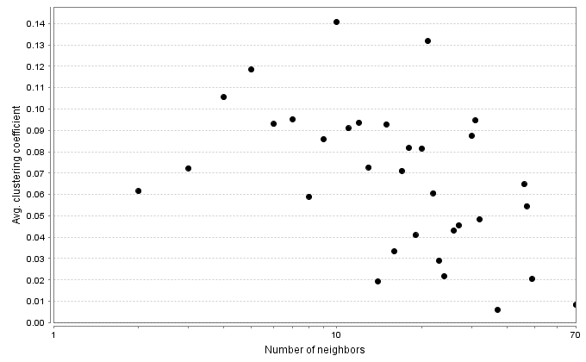
a.
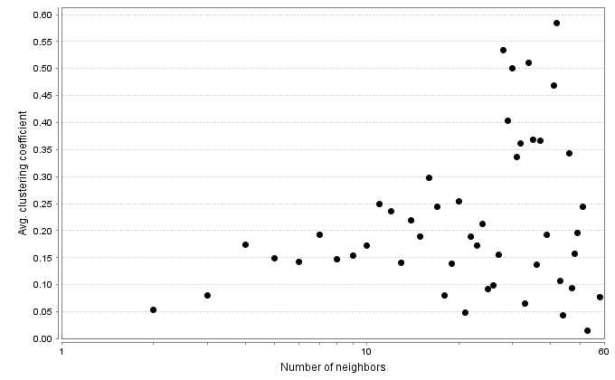
b.
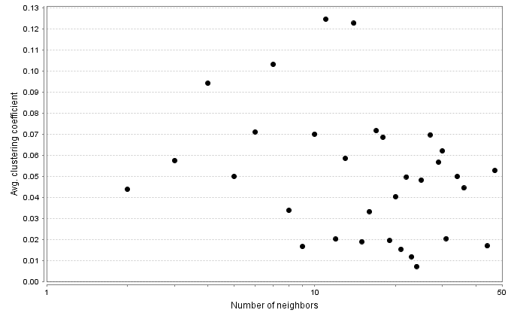
c.

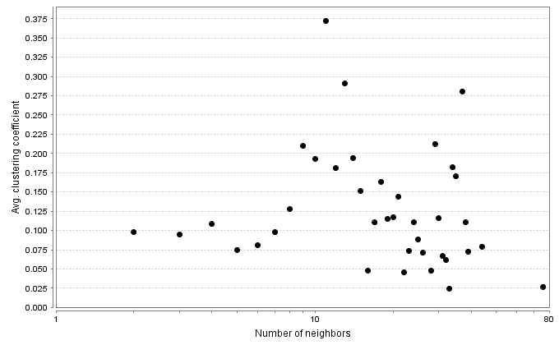
d.
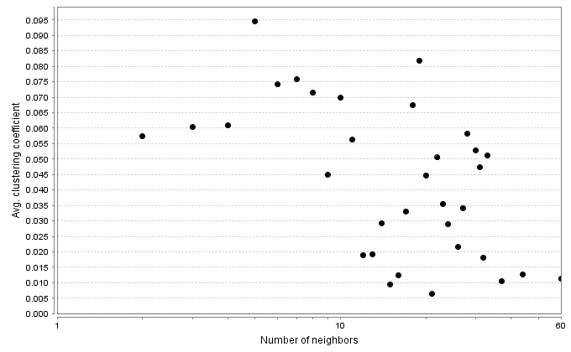
e.
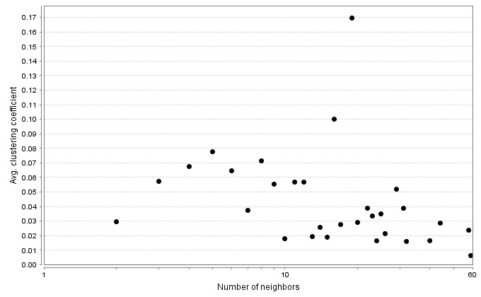
f.
Figure S1.Distribution of clustering coefficients in tenocytes (a), osteocytes (b), adipocites (c), chondrocytes (d) myocyte (e) and neurocyte (f) miRNA- gPPI networks.

