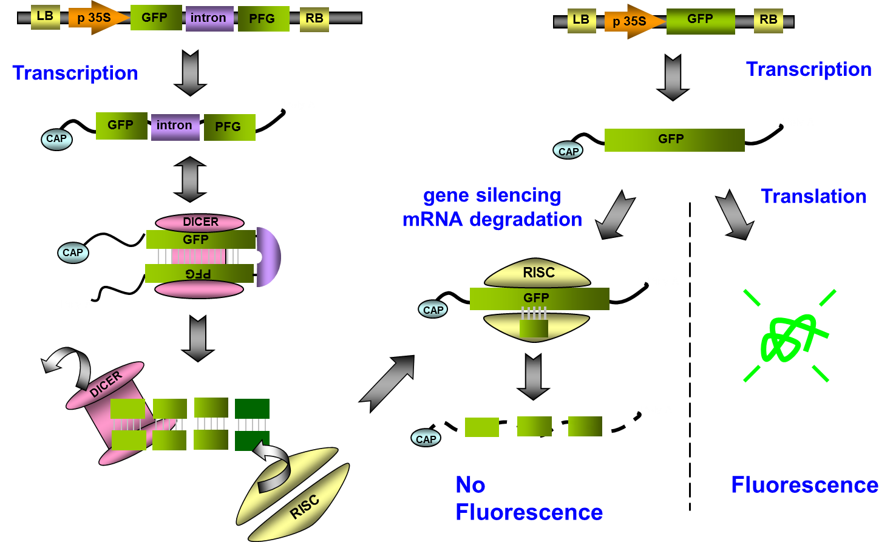
Supplementary Figure 1. The virus induced gene silencing mechanism within plant body. VIGS is a PTGS method used by plants as a defense mechanism against invading viruses. During viral replication double-stranded RNA (dsRNA) is produced by an RNA dependent RNA polymerase and this triggers PTGS. One of the major aspects of this process involves Dicer-like enzyme-mediated cleavage of the dsRNA to produce siRNA. This siRNA binds to and activates the RNA-induced silencing complex (RISC) which cleaves the viral RNA in a homology-dependent manner.

