Supplementary Table 1: Variety details used in the experiment.
Name of Variety | Ecology | Background | Reference
Swarna (MTU 7029) IET 5656 | Rainfed shallow-land variety | Vasista x Mahsuri | http://riceportal.in/content/swarna-mtu-7029-iet-5656
IR-29 | Suited to irrigated and rainfed lowland areas. | IR833-6-2-1-1/  IR1561-149-1 //IR24*4/O. nivara | http://books.irri.org/9712202062_content.pdf
CR Dhan 201 | suitable for water limiting/ aerobic conditions | CR2721-81-3-IR83380-B-B-124-1 | https://icar-nrri.in/popular-nrri-varieties/

Supplementary Table 2: Primer list of GRF genes used for the qRT-PCR analysis
Gene Name | Forward Primer (5’ to 3’) | Reverse Primer (5’ to 3’)
GRF_1 | AGTGGCCGCATGAGAAG | GTGATCGGGAGGTCGTTG
GRF_2 | GTGATCGGGAGGTCGTTG | GCAGATGGTCGCCGTTG
GRF_3 | TTCGACGAGTGGCCAAAG | CCATTGGAATGGAGATCGAGAG
GRF_4 | GCCAAAGGGAAGGGATTCA | AGAAGTCAGAGGATGCCATTG
GRF_5 | GCACGCAGCTCTCCATC | GCAGATGGTCGCCGTTG
GRF_6 | CAGAAGACCACCTTTGGATCAG | AGATCATCCCGCAGGTTACT
GRF_7 | AACCTCTTAGCTGATGGACATAC | CTGCCTGCAGGACTACTAAC
GRF_8 | ATTGCCCATCTGGAATCCTAC | CGGTGCCACCACTATTTACT
GRF_9 | GCACAAATGCAAGAGGATAGC | CGAGGTTCAGTAACCAACCATA
GRF_10 | CGAGGTTCAGTAACCAACCATA | GGGAGAAGACGATGCCA
GRF_11 | TACCTCAGGGTCGAAACCA | TGCCACTGCAAGCTTCTT
GRF_12 | GAAAGCCTATGGAAGCCTCTG | GGGCGAGGAGCACTTTG

Supplementary Table 3: Number of homologs of growth regulating factors (GRFs) gene family, clusters and singletons identified in different species of rice.
Species | Proteins | Clusters | Singletons
Oryza barthii | 11 | 10 | 1
Oryza brachyantha | 10 | 8 | 2
Oryza glaberrima | 10 | 8 | 2
Oryza glumipatula | 12 | 12 | 0
Oryza sativa subsp. indica | 12 | 12 | 0
Oryza longistaminata | 9 | 7 | 2
Oryza meridionalis | 11 | 10 | 1
Oryza nivara | 12 | 12 | 0
Oryza punctata | 12 | 12 | 0
Oryza rufipogon | 12 | 12 | 0
Oryza sativa subsp. japonica | 12 | 11 | 1

Supplementary Table 4: Cluster distribution and functional of GRF orthologs in rice
Cluster no | Swissport Id | GRF No | Function
1 | Q6AWX8 | GRF11 | GA induced stem elongation
2 | Q9FRG8 | GRF9 | DNA-dependent transcription
3 | Q6AWY4 | GRF5 | Transcription activator that plays a regulatory role in gibberellin-induced stem elongation
4 | A2XX57 | GRF3 | cellular response to cold
5 | Q6AWY3 | GRF6 | biosynthetic process
6 | Q6AWY8 | GRF1 | nucleobase-containing compound metabolic process
8 | Q6AWY2 | GRF7 | ATP binding DNA templated transcription
10 | Q6EPP9 | GRF10 | nucleobase-containing compound metabolic process
9 | Q9LD83 | GRF12 | Guard cell S-type anion channel SLAC1 regulates stomata opening
7 | Q6AWY1 | GRF8 | regulation of DNA-templated transcription
12 | Q6ZIK5 | GRF4 | plays a regulatory role in grain development
11 | Q6AWY7 | GRF2 | DNA-templated transcription

Supplementary Table 5: Descriptive statistics of different traits studied in the aerobic and non-aerobic conditions. PH-Vegetative plant height, LN- Leaf Number, NT- Number of Tillers, SPAD- Soil plant analysis development, LL- Leaf length, LW- Leaf width, RA- Root Area, SA- Shoot Area, FSW- Fresh shoot weight, FRW- Fresh Root Weight, DSW- Dry Shoot Weight, DRW- Dry root weight. Unit of measurements is given in the brackets adjacent to the different traits name.
Trait | Mean | Standard Error | Median | Standard Deviation | Kurtosis | Skewness | Range | Minimum | Maximum | Confidence Level (95.0%)
PH-25d (in cm) | 24.58 | 1.62 | 25.02 | 3.98 | -1.05 | -0.38 | 10.49 | 18.81 | 29.3 | 4.17
PH-36d (in cm) | 37.04 | 2.56 | 36.88 | 6.26 | -0.94 | -0.28 | 16.41 | 27.81 | 44.22 | 6.57
PH-46d (in cm) | 45.17 | 4.1 | 47.83 | 10.05 | -1.78 | -0.56 | 23.96 | 31.57 | 55.53 | 10.54
PH-60d (in cm) | 59.29 | 5.58 | 58.56 | 13.68 | -0.47 | -0.13 | 38.01 | 39.3 | 77.31 | 14.35
LN-25d | 4.38 | 0.19 | 4.44 | 0.46 | 2.88 | -1.18 | 1.39 | 3.56 | 4.94 | 0.48
LN-36d | 12.13 | 0.68 | 11.69 | 1.66 | -1.87 | 0.53 | 3.94 | 10.5 | 14.44 | 1.74
LN-60d | 42.41 | 4.23 | 43.06 | 10.35 | 0.34 | -0.44 | 29.89 | 26.11 | 56 | 10.86
NT-36D | 3.74 | 0.2 | 3.72 | 0.48 | -1.02 | 0.33 | 1.28 | 3.17 | 4.44 | 0.5
NT-46d | 5.24 | 0.22 | 5.17 | 0.53 | -0.4 | 0.57 | 1.46 | 4.61 | 6.07 | 0.56
NT-60d | 12.37 | 1.47 | 12.22 | 3.6 | -2.14 | 0.09 | 8.78 | 8.11 | 16.89 | 3.78
SPAD-25d | 27.65 | 0.92 | 27.35 | 2.26 | 0.01 | 0.62 | 6.33 | 24.92 | 31.25 | 2.37
SPAD-36d | 31.27 | 0.66 | 30.7 | 1.62 | 2.18 | 1.41 | 4.6 | 29.6 | 34.2 | 1.7
SPAD-46d | 30.79 | 1.42 | 29.81 | 3.48 | -1.37 | 0.63 | 8.76 | 27.08 | 35.85 | 3.65
SPAD-60d | 42.6 | 0.59 | 41.95 | 1.43 | -0.53 | 1.01 | 3.7 | 41.19 | 44.89 | 1.51
LL-60d (in cm) | 34.44 | 2.67 | 36.37 | 6.53 | -1.66 | -0.51 | 15.63 | 26.41 | 42.04 | 6.85
LW-60d (in cm) | 0.96 | 0.07 | 0.96 | 0.16 | -1.45 | 0.3 | 0.4 | 0.79 | 1.19 | 0.17
RA-60d (in cm²) | 2445.11 | 210.33 | 2561.45 | 515.21 | -1.46 | -0.57 | 1214.74 | 1671.92 | 2886.66 | 540.68
SA-60d (in cm²) | 5497.27 | 250.88 | 5467.11 | 614.53 | 0.86 | -0.71 | 1751.67 | 4474.83 | 6226.5 | 644.91
FSW-60d (in mg) | 16.21 | 1.9 | 15.37 | 4.65 | 1.24 | 0.95 | 13.44 | 10.71 | 24.15 | 4.88
FRW-60d (in mg) | 5.57 | 1.28 | 5.23 | 3.14 | -2.69 | 0.05 | 7.07 | 1.91 | 8.98 | 3.3
DSW-60d (in mg) | 4.55 | 0.44 | 4.22 | 1.07 | -0.93 | 0.37 | 2.88 | 3.15 | 6.03 | 1.12
DRW-60d (in mg) | 0.96 | 0.16 | 0.82 | 0.4 | 1.46 | 1.32 | 1.1 | 0.57 | 1.66 | 0.42

Supplementary Table 6: Mean and standard deviation of the different morphological parameters studied in three different varieties under aerobic and non-aerobic conditions. A-Aerobic, F-Non-aerobic. PH-Vegetative plant height, LN- Leaf Number, NT- Number of Tillers, SPAD- Soil plant analysis development, LL- Leaf length, LW- Leaf width, RA- Root Area, SA- Shoot Area, FSW- Fresh shoot weight, FRW- Fresh Root Weight, DSW- Dry Shoot Weight, DRW- Dry root weight.
Trait | Swarna A | Swarna F | IR29 A | IR29 F | CR201A | CR201F
PH-25d (in cm) | 21.33±2.31 | 21.64±1.03 | 27.36±1.14 | 29.21±0.73 | 26.41±2.83 | 24.67±7.09
PH-36d (in cm) | 28.33±1.37 | 32.58±2.18 | 40.65±1.16 | 44.15±0.63 | 34.1±5.53 | 41.47±6.76
PH-46d (in cm) | 31.3±0.93 | 32.07±6.3 | 48.73±1.64 | 52.98±2.16 | 48.76±1.16 | 51.98±5.05
PH-60d (in cm) | 39.3±1.64 | 50.97±1.99 | 59.61±2.4 | 77.31±6.47 | 57.5±2.66 | 71.05±5.69
LN-25d | 3.66±0 | 4.55±0.69 | 4.44±0.5 | 4.88±0.19 | 4.33±0.88 | 4.44±0.69
LN-36d | 11.22±0.69 | 14.66±3.75 | 10.44±1.92 | 12±0.57 | 11.66±2.02 | 13.11±3.68
LN-60d | 41.33±2.18 | 56±6.11 | 26.11±3.09 | 36.88±1.26 | 44.77±5.73 | 49.33±10.08
NT-36D | 3.22±0.38 | 4.44±0.96 | 3.11±0.5 | 4±0 | 3.22±1.01 | 3.77±1.34
NT-46d | 5.11±0.38 | 5.22±0.96 | 4.77±0.5 | 4.88±0.38 | 5.11±0.19 | 6.88±3
NT-60d | 9.55±0.38 | 17.22±0.76 | 24.67±30.04 | 13.77±2.21 | 10.66±0.57 | 15.66±3.38
SPAD-25d | 31.11±2.5 | 29.31±1.43 | 27.63±1.12 | 25.44±0.63 | 24.94±1.81 | 25.1±2.63
SPAD-36d | 29.6±1.8 | 30.5±0.96 | 30.5±1.13 | 31.9±0.91 | 30.9±1.16 | 34.2±2.73
SPAD-46d | 33.17±2.18 | 35.77±3.64 | 27.72±1.51 | 27.65±0.73 | 28.92±0 | 29.32±1.92
SPAD-60d | 43.9±4.3 | 43.93±1.5 | 40.96±4.62 | 41.03±1.04 | 41.73±1 | 41.06±0.25
LL-60d (in cm) | 26.33±1.05 | 32.73±1.5 | 37.26±6.35 | 42.33±5.57 | 38.13±5.18 | 43.3±4.25
LW-60d (in cm) | 1±0.1 | 1.03±0.15 | 1.36±0.5 | 1.23±0.25 | 0.8±0.09 | 0.76±0.15
RA-60d (in cm²) | 1671.91±452.07 | 2876.52±429.13 | 2246.38±396.03 | 2104.78±580.7 | 2886.65±209.44 | 2884.41±406.52
SA-60d (in cm²) | 4474.83±676.17 | 5383.98±785.23 | 5550.24±886.33 | 6015.3±995.13 | 5332.78±761.12 | 6226.5±913.66
FSW-60d (in mg) | 10.71±0.87 | 15.52±5.93 | 13.29±3.38 | 18.36±3.02 | 15.21±10.3 | 24.15±9.72
FRW-60d (in mg) | 1.91±0.4 | 8.98±3.61 | 3.24±1.18 | 7.2±4.63 | 3.23±2.32 | 8.84±4.32
DSW-60d (in mg) | 3.15±0.2 | 4.23±1.45 | 4.07±0.93 | 5.61±0.93 | 4.2±2.8 | 6.03±2.18
DRW-60d (in mg) | 0.33±0.09 | 0.83±0.16 | 0.72±0.15 | 1.17±0.82 | 0.81±0.56 | 1.66±1.3

Supplementary Table 7A: Two-way ANOVA for varieties and traits
Source of Variation | SS | df | MS | F | P-value | F crit
Varieties | 217765.5 | 5 | 43553.1 | 4.778385 | 0.000350116 | 2.25164871
Traits | 1.01E+08 | 19 | 5290852 | 580.4805 | 1.1448E-188 | 1.630056476
Varieties x Trait | 3772356 | 95 | 39709.01 | 4.356634 | 2.00739E-20 | 1.313986713
Within | 2187506 | 240 | 9114.608
Total | 1.07E+08 | 359

Supplementary Table 7B: Two-way ANOVA for conditions (Aerobic and Non-aerobic) and traits for all three varieties
Source of Variation | SS | df | MS | F | P-value | F crit
Conditions | 39692.98 | 1 | 39692.98 | 2.149881786 | 0.143614482 | 3.872229
Traits | 1E+08 | 18 | 5570175 | 301.6961091 | 7.3683E-182 | 1.637882
Conditions x Traits | 524939.9 | 18 | 29163.33 | 1.579566717 | 0.063807951 | 1.637882
Within | 5612711 | 304 | 18462.87
Total | 1.06E+08 | 341

Supplementary Table 7C: Two-way ANOVA for conditions (Aerobic and Non-aerobic) and traits in Swarna variety
Source of Variation | SS | df | MS | F | P-value | F crit
Conditions (Swarna) | 121035.4 | 1 | 121035.4 | 12.45365 | 0.000695 | 3.960352
Traits | 28994706 | 19 | 1526037 | 157.018 | 3.39E-55 | 1.718026
Interaction | 2056435 | 19 | 108233.4 | 11.13642 | 2.15E-15 | 1.718026
Within | 777509.6 | 80 | 9718.869
Total | 31949686 | 119

Supplementary Table 7D: Two-way ANOVA for conditions (Aerobic and Non-aerobic) and traits in CR Dhan 201 variety
Source of Variation | SS | df | MS | F | P-value | F crit
Conditions (IR29) | 2667.382 | 1 | 2667.382 | 0.19047 | 0.663701 | 3.960352
Columns | 23564852 | 19 | 1240255 | 88.56298 | 1.15E-45 | 1.718026
Interaction | 14927.49 | 19 | 785.6572 | 0.056101 | 1 | 1.718026
Within | 1120338 | 80 | 14004.22
Total | 24702784 | 119

Supplementary Table 7E: Two-way ANOVA for conditions (Aerobic and Non-aerobic) and traits in IR29 variety
Source of Variation | SS | df | MS | F | P-value | F crit
Conditions (CR Dhan 201) | 234.1099 | 1 | 234.1099 | 0.044632 | 0.833219 | 3.960352
Columns | 46752800 | 19 | 2460674 | 469.1164 | 7.66E-74 | 1.718026
Interaction | 441.9509 | 19 | 23.26058 | 0.004435 | 1 | 1.718026
Within | 419626.9 | 80 | 5245.337
Total | 47173103 | 119

Supplementary Table 8: Linear regression value between aerobic and non-aerobic conditions.
Trait Name | Linear regression R² Value
PH25d | 0.3344
PH36d | 0.8749
PH46d | 0.8387
PH60d | 0.8491
LN25d | 0.0035
LN36d | 0.057
LN60d | 0.2613
NT36d | 0.1567
Nt46d | 0.0004
NT60d | 0.0272
SPAD25d | 0.3875
SPAD46d | 0.5799
SPAD60d | 0.0031
LL60d | 0.2223
LW60d | 0.8189
RA60d | 0.0007
FSW60d | 0.002
FRW60d | 0.0094
DSW60d | 0.0003
DRW60d | 0.0175

Supplementary Figure 1: Motif representations of GRF gene family in different species of rice
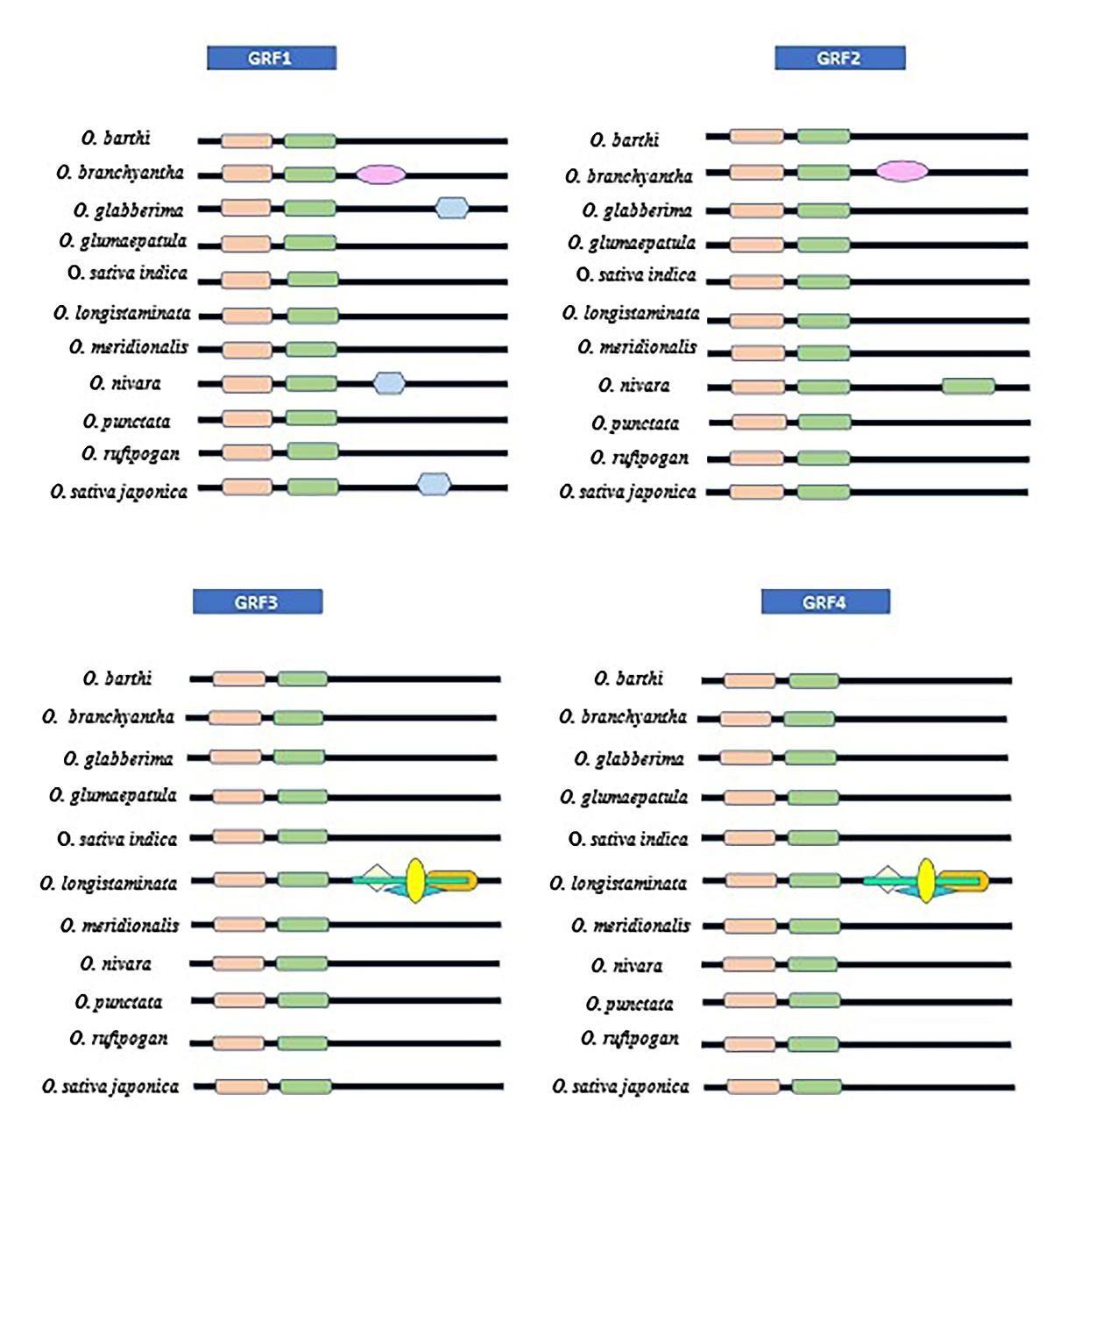
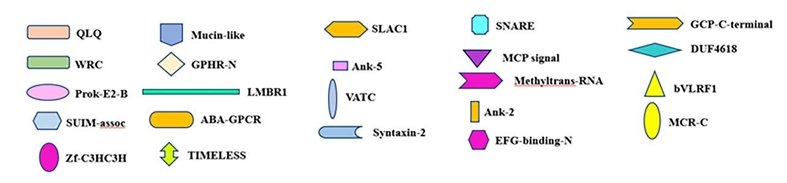

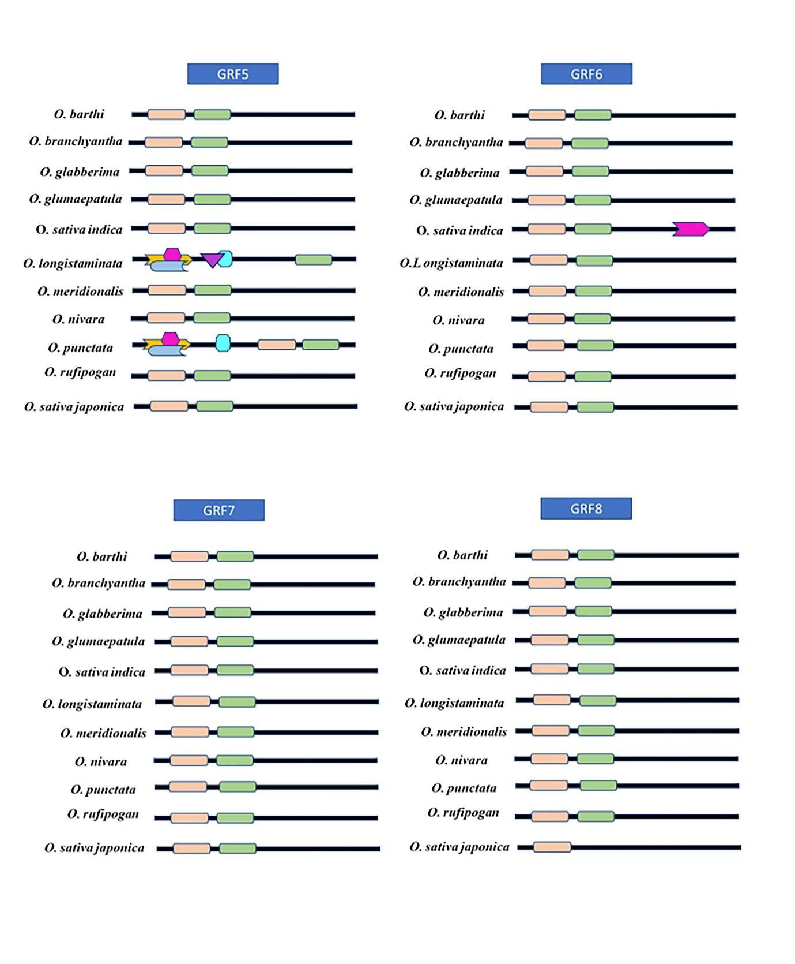
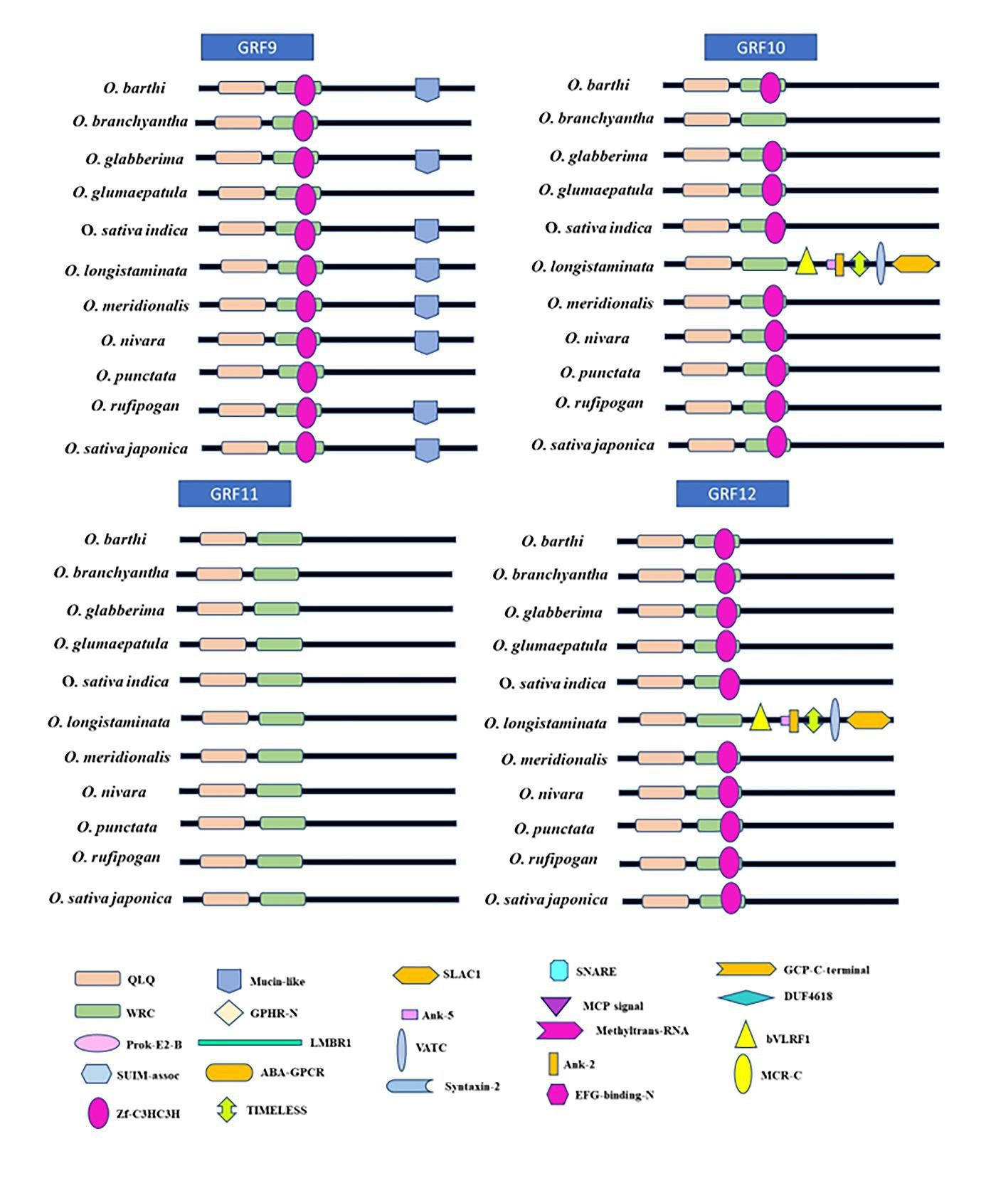

‘
Supplementary Figure 2: Orthologous clusters containing all GRF proteins represented by eleven species of rice.
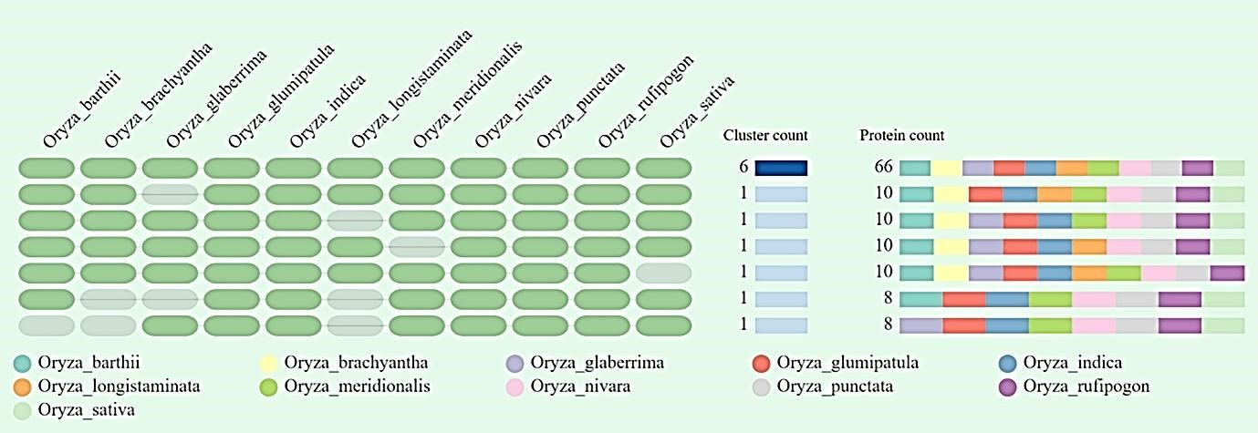

Supplementary Figure 3: Correlation analysis between traits and conditions in three different rice varieties. PH-Vegetative plant height, LN- Leaf Number, NT- Number of Tillers, SPAD- Soil plant analysis development, LL- Leaf length, LW- Leaf width, RA- Root Area, SA- Shoot Area, FSW- Fresh shoot weight, FRW- Fresh Root Weight, DSW- Dry Shoot Weight, DRW- Dry root weight
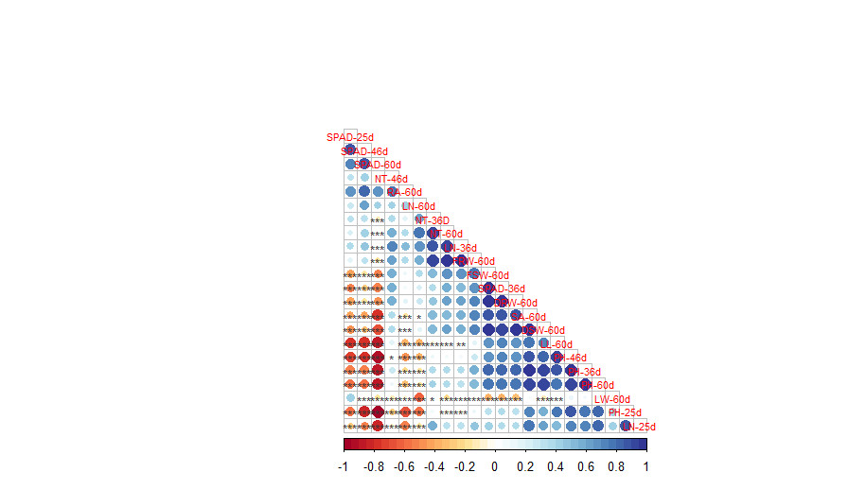
Level of Significance: ‘***’ 0.001 ‘**’ 0.01 ‘*’ 0.05

